Competator tool vs Ours
1- Compititor tool in overview page
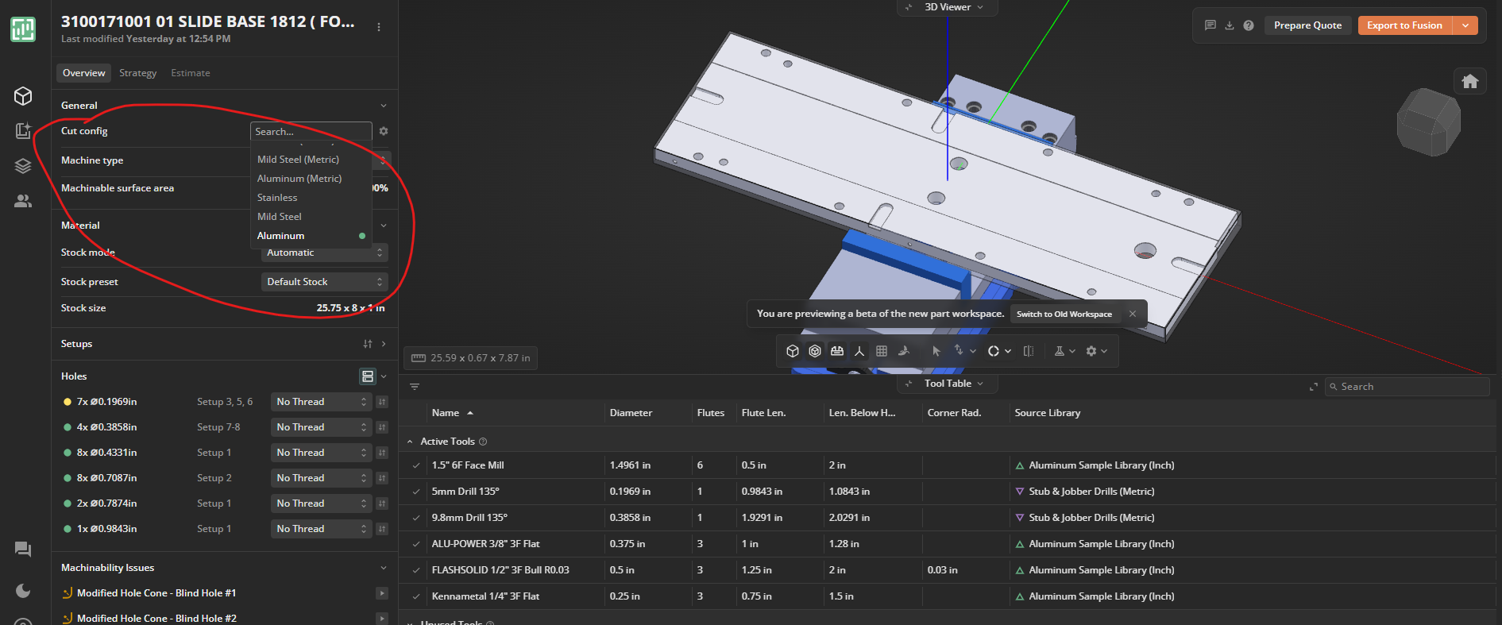
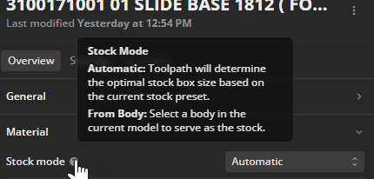
material selection oir cut config not in ours
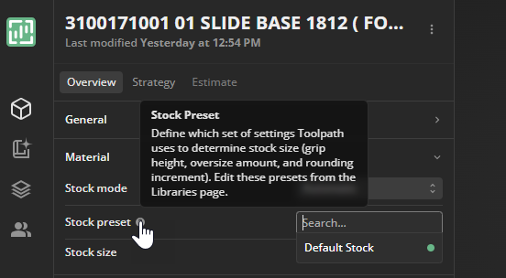
stock preset not in ours

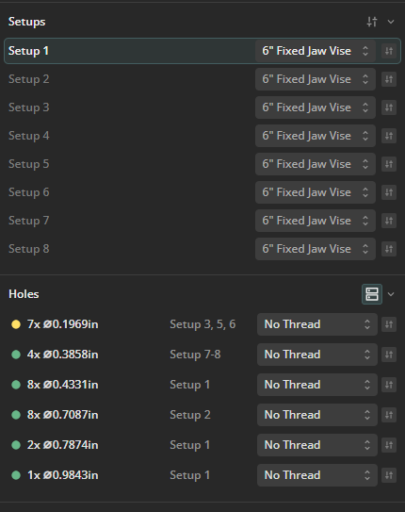
Not in ours

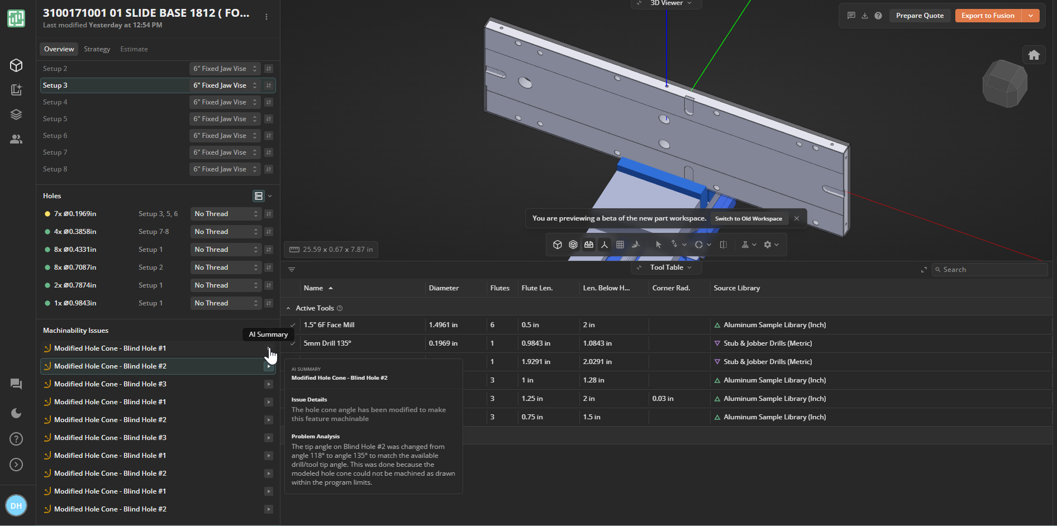
In the machinability issues when we select that arrow on the right, if you see the highlighted one, an AI summary is going to appear. There are changes on the table or at least the AI summary gives a proper summary and kind of things which are not there in our tool.

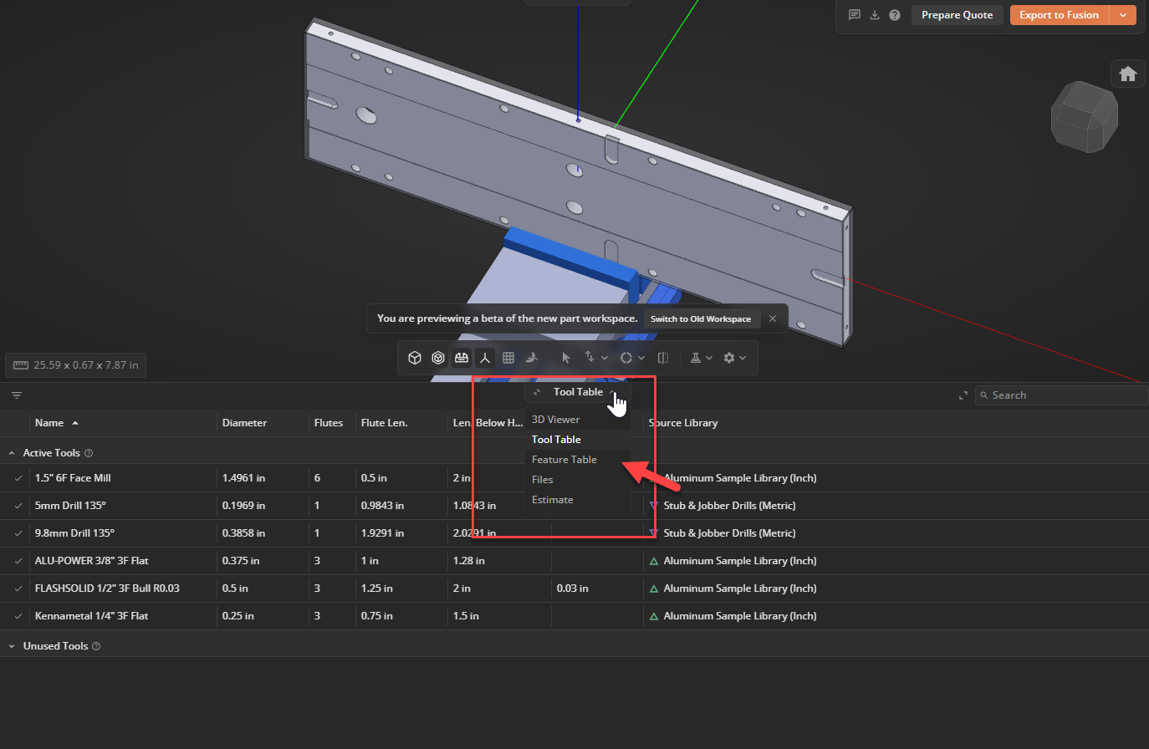
Here actually you can switch between:
- 3D viewer
- feature table
- file
- estimate
which is a very good feature actually in the same string itself.
And you look at it we don't have the option of a stock size or anything, which we had in the streamlit one, we were able to change it but in this way I don't see any option like that.

Strategy tab
